Unit 3 Review Name ____________________________________

1. Unit Conversions
2. Convert 1091 yards to miles
3. Convert 76 kilograms to ounces
4. Convert 8 days to seconds
5. 3 hectoliters to milliliters
6. 10000 centigrams to grams
7. 7800 decimeters to decameters
8. Find the Area and Perimeter of Each Figure

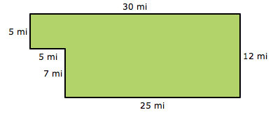

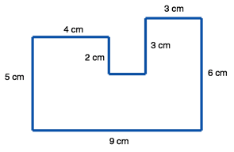

2. 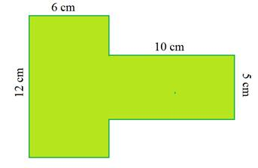
3. 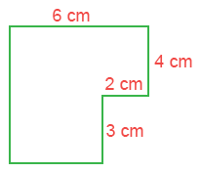
4. Dilation and Scale



15. Graph the polygon and graph the scaled polygon

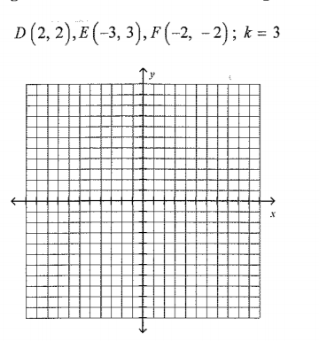

16. Identify the scale factor

