Writing Linear Equations Stations Activity

Objectives:
- To graph linear equations.
- To complete a table of values for each equation.
- To identify the slope of linear equations in slope-intercept form.
- To identify the y-intercept of linear equations in slope-intercept form.
- To explain the effects of “m” on a linear function in slope-intercept form.
- To explain the effects of “b” on a linear function in slope-intercept form.

Vocabulary:
- linear function: a function used to create a line
- parent function: the most basic form of a function, before adding constants
- slope: the amount that the function increases or decreases as the x-value changes; the “m” value in an equation in slope-intercept form
- y-intercept: the point on a graph where the line crosses the y-axis
- slope-intercept form: linear equation in the form y = mx + b
- x-axis: the horizontal axis
- y-axis: the vertical axis
Station 1
IF.4&5L: I can identify the slope and y-intercept of a linear function.

- Y = 2X – 7 2. Y = - -3
m = _________ m = _________
y –int. __________ y –intercept = _ _______

- Y = -2 4. Y = -3X +
m = _________ m = _________
- y –intercept = _ _______ y –intercept = _ _______

5.
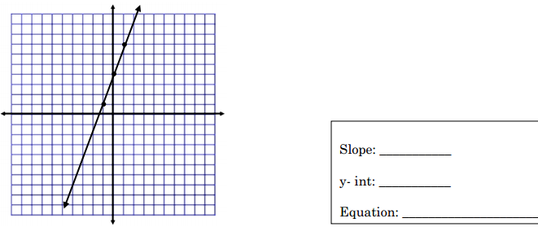
6.
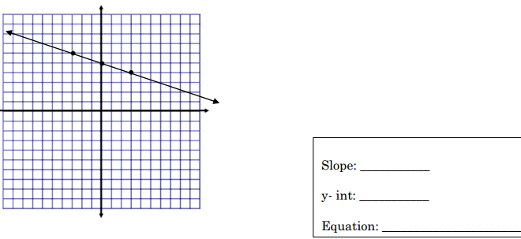
Station 2
REI.10&11L: I can write the equation of the line given the slope and y – intercept.
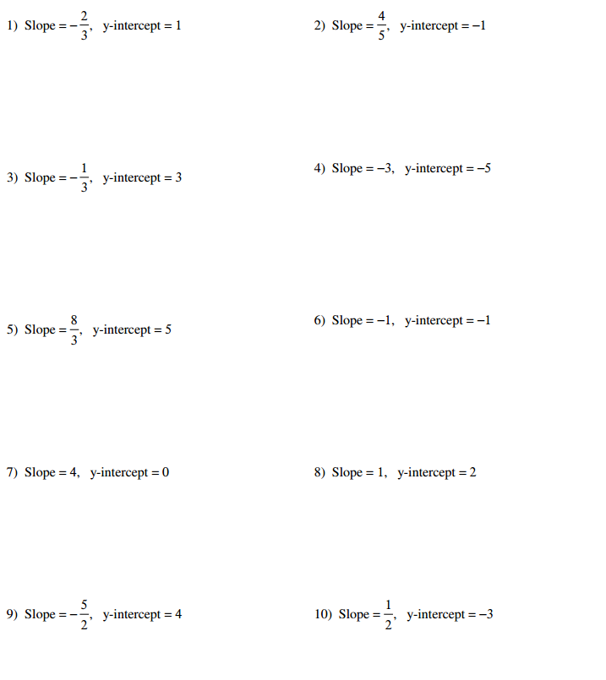
You are visiting Baltimore, MD and a taxi company charges a flat fee of $3.00 for using the taxi and $0.75 per mile.

A. Write an equation that you could use to find the cost of the taxi ride in Baltimore, MD. Let x represent the number of miles and y represent the total cost.
B. How much would a taxi ride for 8 miles cost?
C. If a taxi ride cost $15, how many miles did the taxi travel?
Station 3
REI.10&11L: I can sketch the line of each graph.

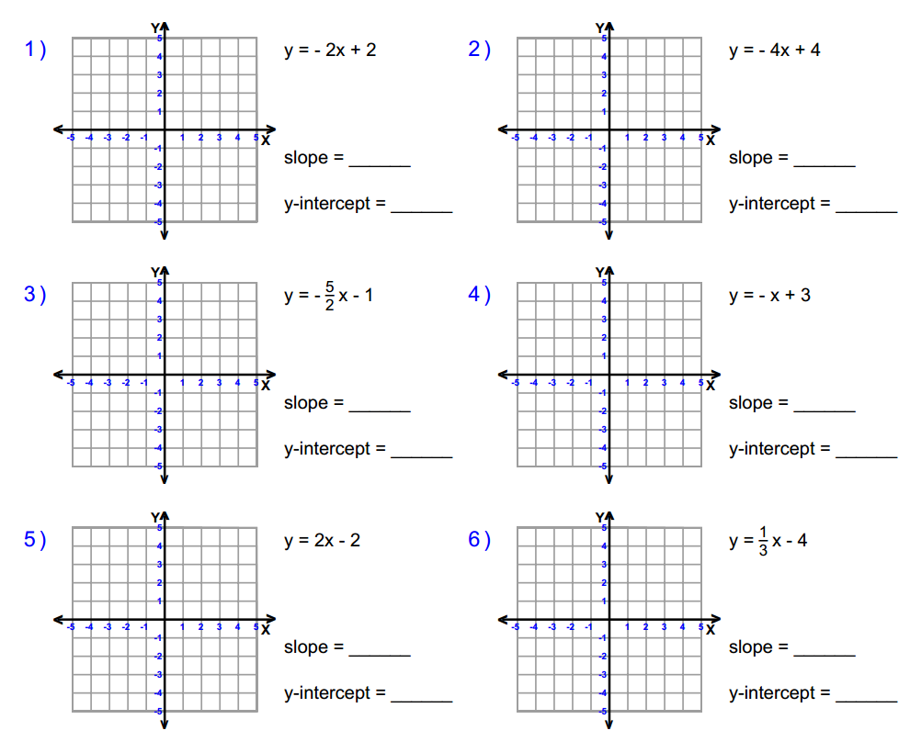

Station 4:
IF.4&5L: I can identify key characteristics of a line based on its equation.
Equation A: y = 2x + 1
x | y
-2
-1
0
1
2
Fill in the table of values:

Answer the following questions:
- What is the slope of the function? _____
- What does the slope tell you about the graph?
- What is the y-intercept? (_____, _____)
- What does the y-intercept tell you about the graph?

Equation B: y = -2x + 1
x | y
-2
-1
0
1
2
Fill in the table of values:

Answer the following questions:
- What is the slope of the function? _____
- What does the slope tell you about the graph?
- What is the y-intercept? (_____, _____)
- What does the y-intercept tell you about the graph?
Station 5
ACED.4L: I can rearrange standard form equations into slope-intercept form to identify key characteristics

Rewrite the equations in slope intercept form, y = mx + b, identify the slope and y - intercept.

