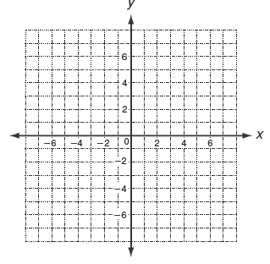

I can find **SLOPE (M)** from…

|  |  |
| --- | --- |
| ***x*** | ***f(x)*** |
| -1 | -2 |
| 2 | 4 |
| 4 | 8 |
| 5 | 10 |
| 8 | 16 |

*y* = -2*x* + 5

(2, -3)

(5, -6)

***Equation***

***Ordered Pairs***

***Table***

***Graph***

**Slope-Intercept Form**

***y* = M*x* + B**

**Equation of a Line!**

 

**RATIO – Division!**

|  |  |
| --- | --- |
| ***x*** | ***f(x)*** |
| -1 | -2 |
| 2 | 4 |
| 4 | 8 |
| 5 | 10 |
| 8 | 16 |

 

***\*\* Check your slope! \*\****

Positive Slope

Negative Slope

**Ex:** Find the slope of the line that passes through the points

(2, -3) (5, -6)

 

*Remember, y goes* ***first*** *(on top)!*

*This is* ***opposite*** *of graphing ordered pairs,*

*where you go x first (x, y).*

**Rate of Change RATIO Steepness of a Line**

**Ex:** Find the slope:

y = -2x + 5

y = ¼x + 3

y = x

**SLOPE (M)**

**SLOPE (M)**

**SLOPE (M)**

**SLOPE (M)**